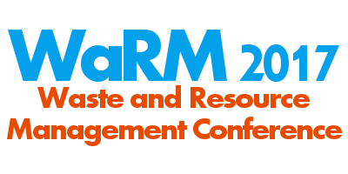

Date: 20th June 2017
Venue: Hub Theatre, Open University, Walton Hall, Milton Keynes MK7 6AA
Registration: www.open.ac.uk/warm2017
09.30-10.15 | Welcome, registration and coffee
10.15-10.40 | Introduction/ Keynote 1 | Linda Crichton (WRAP)
10.40-11.00 | Improved testing for the pathogenic fungi Aspergillus fumigatus | Ceri Gwyther (Open University)
11.00-11.20 | Use of sequential extraction to improve waste management | Kiri Rodgers (University of the West of Scotland)
11.20-11.40 | Coffee Break
11.40-12.00 | Internet of things supporting sustainable food systems | Amel Bennaceur (Open University)
12.00-12.20 | Robust and reliable treatment of leachate at a closed landfill site in Sussex, UK | Tim Robinson (Phoenix Engineering)
12.20-12.40 | Exploring waste tyre problems and sustainable waste management in the Tunisian context | Munir Abuzukhar (University of Salford)
12.40-1.40 | Lunch and posters
1.40-2.00 | Keynote 2 | Margaret Bates (CIWM)
2.00-2.20 | Scampi and Scottish socks: Glasgow’s laundry threatens one of the UK’s last great fisheries | Natalie Welden (Open University)
2.20-2.40 | Community repair: enabling repair as part of the movement towards a circular economy | Alex Gnanapragasam (Nottingham Trent University)
2.40-3.00 | Coffee Break
3.00-3.20 | Prospecting secondary raw materials in the urban mine and mining wastes | Sarah Downs (Repic)
3.20-3.40 | Upcycling wastes to recover valuable chemicals or materials | Simon Collinson (Open University)
3.40-4.00 | Prizes and conference close

